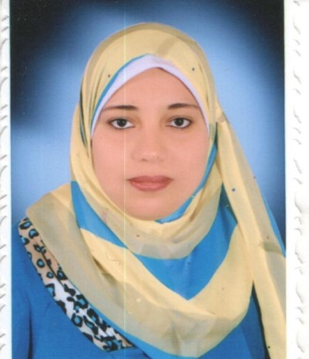
Abeer Abdelwares Mahmoud Abdelwares Address: Assiut- Elwalidia
Personal Information: Date of Birth : 6th April 1992
Marital status: Single
Nationality: Egyptian
Email: - abeer199246@yahoo.com
Job:-Demonsteator Aimal Medicine Deprtment Faculty of Veterinary Medicine - Assiut University
Education & Qualifications :
Bachelor of Veterinary Medical Science with honors in October 2014
Skills: Languages- : Arabic : Mother Tongue
English: Very Good written, spoken and Translation Computer- : Keen user of the Internet.
*Personal Skills :
- Communication Skills . - Self confidence.
- Responsibility. - Perseverance.
- Team Work . - Setting Goals.
- Ability to work under pressure - Creative
- Cooperative
FLDC certificates:
Conference Organization (2014)
University Administration (2014)
Time and Conference Management (2015)
International Publishing of Research (2015)
Quality Standars in Teaching₁ (2015)
How to CompeteaResearch Fund (2015)

Certificates:
English language Level one (2007)
English language Level Two (2007)
English language Level three (2008)--- ICDL (2013)
Presentation about Fractures of the bone in Horse (2012) from المؤتمر العلمى الخامس عشر
Participation from AVSSA (2012)
Training on End Note program me from مركز الخريجين كلية الطب البيطرى
Hobbies: Traveling, Reading, and Surfing Internet.
References: Academic and professional references are available on request.

